*Coal lab Homework-01*

*Q1(a):*

*[org 0x0100]*

*jmp start*

*num: dw 1,9,0,0,6,0*

*length: dw 6*

*second_largest: dw 0*

*max: dw 0*

*nextLargest :*

*mov ax, [num+bx]*

*mov [max], ax*

*add bx, 2*

*sub cx, 1*

*jz terminate*

*jnz compareloop*

*start :*

*mov ax, [num]*

*mov [max], ax*

*mov bx, 2*

*mov cx, [length]*

*compareloop :*

*cmp ax, [num+bx]*

*jnae nextLargest*

*mov dx, [num+bx]*

*mov [second_largest], dx*

*add bx, 2*

*sub cx, 1*

*jnz compareloop*

*jz terminate*

*terminate:*

*mov ax, 0x4c00*

*int 0x21*

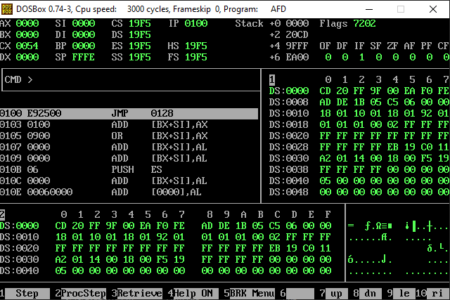

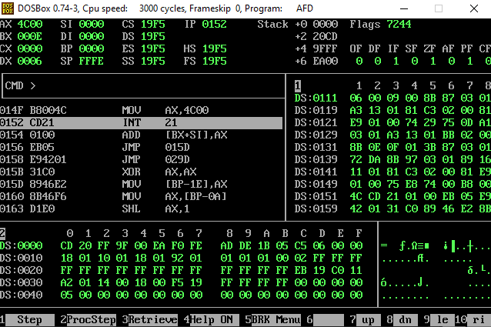

*Q1(b):*

*[org 0x0100]*

*jmp start*

*num:dw 1,9,0,0,6,0*

*length:dw 6*

*smaller:dw 0*

*secondsmallest:dw 0*

*nextsmall:*

*mov ax,[smaller]*

*mov [secondsmallest],ax*

*mov ax,[num+bx]*

*mov [smaller],ax*

*add bx,2*

*sub cx,1*

*jz terminate*

*jnz compareloop*

*start:*

*mov dx,9*

*mov ax,[num]*

*mov [smaller],ax*

*mov bx,2*

*mov cx,[length]*

*compareloop:*

*cmp ax,[num+bx]*

*jae nextsmall*

*mov dx,[secondsmallest]*

*cmp dx,[num+bx]*

*jbe skip*

*mov [secondsmallest],dx*

*skip:*

*add bx,2*

*sub cx,1*

*jnz compareloop*

*jz terminate*

*terminate:*

*mov ax,0x4c00*

*int 0x21*

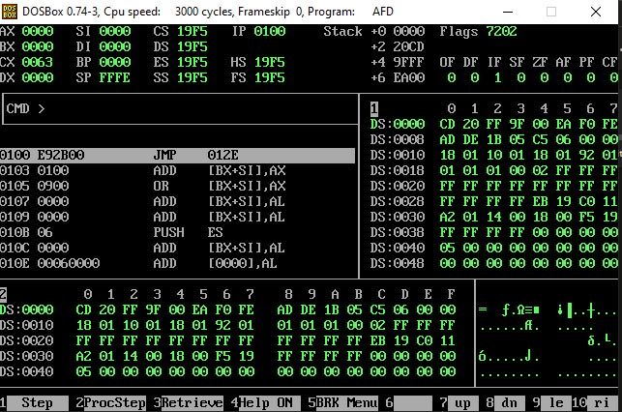

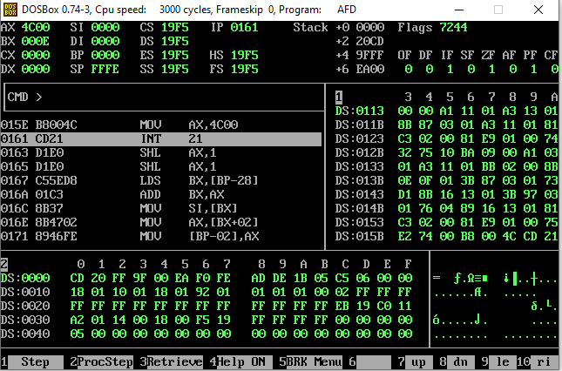

*Coal lab Homework-02*

*Q2:*

*[org 0x0100]*

*mov cx, 6*

*outerloop:*

*mov bx, 0*

*innerloop:*

*mov ax, [data + bx]*

*cmp ax, [data + bx + 2]*

*jnb noswap*

*mov dx, [data + bx + 2]*

*mov [data + bx + 2], ax*

*mov [data + bx], dx*

*noswap:*

*add bx, 2*

*cmp bx, 6*

*jne innerloop*

*loop outerloop*

*mov ax, 0x4c00*

*int 0x21*

*data: dw 1,9,0,0,6,0*

